xBRMS USER GUIDE

**Revision History**

|  |  |  |  |
| --- | --- | --- | --- |
| **Rev** | **Date** | **Author** | **Description** |
| 1.0 | 5/1/2012 | Arkady Glabek | Initial version |
| 1.1 | 8/16/2012 | Iwona Glabek | Changes to the health monitoring page and new performance metrics page. |
| 1.1 | 10/1/2012 | Stephen Beecroft | Misc. edits |
| 1.5 | 02/05/2012 | Iwona Glabek | Added 1.4 and 1.5 functionality |
| 1.5 | 02/11/2013 | Slava Minyailov | Added 1.6 functionality |
| 1.6 | 03/15/2013  04/1/2013 | Scott Salley  Mark Mecham | Added 1.6 Power Management  Updates for 1.6, screen shots |
| 1.6 | 04/09/2013 | Iwona Glabek | Updates for 1.6 functionality |

**Document Approvers & Sign-Off**

|  |  |  |  |
| --- | --- | --- | --- |
| **Date** | **Approver** | **Role** | **Document Accept/Reject** |
| 5/1/2012 | Ric Merrifield | Release Manager | Accept |
| 5/11/2012 | John Stiehl | Release Manager | Accept |
| 4/10/2013 | Mark Mecham | QA Manager | Accept |

**Table of Contents**

1 Introduction 4

1.1 Purpose 4

1.2 Scope 4

1.3 Assumptions and Constraints 4

1.4 Definitions 4

2 System Health - Monitoring 7

2.1.1 Adding New System to Monitor 9

2.1.2 Removing a System to Monitor 10

2.1.3 Deactivating Monitored System 10

2.1.4 Activating a Previously Deactivated System 10

2.1.5 Refreshing Monitored System Status 11

2.1.6 Accessing Readers Health Status 11

2.1.7 Accessing Performance Metrics 12

2.1.8 Readers Health 14

2.1.9 Reader Commands 15

2.1.10 xBRMS Health Status 15

3 Global Server 16

3.1 Login in admin mode 16

3.2 Login in as Maintenance Mode 17

3.3 Assign Readers 18

3.4 Replace Readers 23

3.5 Edit Global xBRMS Properties 27

3.6 Parks Setup 28

4 xBRC & xBRMS Configuration 30

4.1 Edit xBRC Properties 30

4.2 Manage xBRC Configurations 33

4.2.1 Add a stored xBRC Configuration 34

4.2.2 Deploying Stored Configuration 35

4.2.3 Downloading a Stored Configuration 37

4.2.4 Removing Stored Configuration 37

4.3 Edit xBRMS Properties 37

5 Power Management 38

# Introduction

## Purpose

This document describes functionality available in the xBRMS UI from both an Administrator role as well as Maintenance.

## Scope

This document provides instructions on how to use the xBRMS screens accessible from the xBRMS **Home Page** http://<xBRMS_IP>:8080/XBRMSUI

## Assumptions and Constraints

Mozilla Firefox, Chrome, and IE8 with Chrome Frame and are the recommended browsers.

## Definitions

|  |  |
| --- | --- |
| **Terms** | **Definition** |
| xBRMS | xBand Reader Management System |
| xBRC | xBand Reader Controller |
| HA | High Availability |
| HA Pair/Group | All applications accessible using the same VIP address |
| VIP | Virtual Internet Protocol address |

When logging in as Admin, the following screen is displayed if the xBRMS UI application is configured to serve multiple parks.

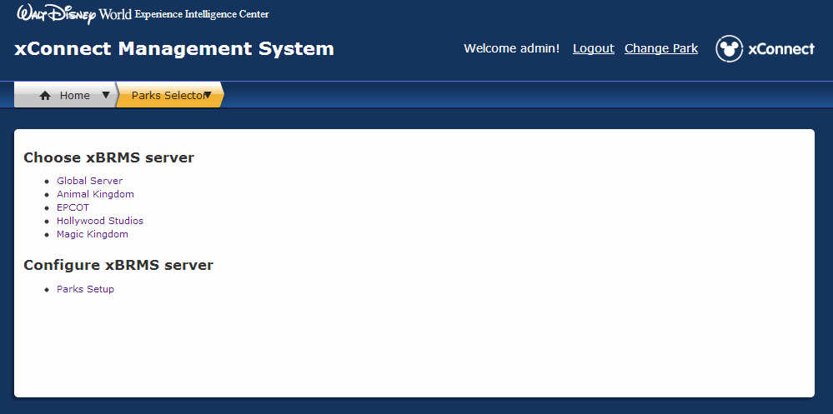

Figure : xBRMS Admin Home Page

In order to connect to an xBRC server dedicated to a specific park, clink on one of the links in the parks list. Once connected to a park, you can always change your selection by clicking on the “Change Park” link in the upper right corner of the screen.

Note that you can view all the parks and the global server’s information concurrently by opening each of them in a separate browser tab or a browser window.

As admin, you have the choice to select **Global Server**, or **Parks Setup** where xBRMS configuration is performed.

The following screen is displayed once a Park is selected

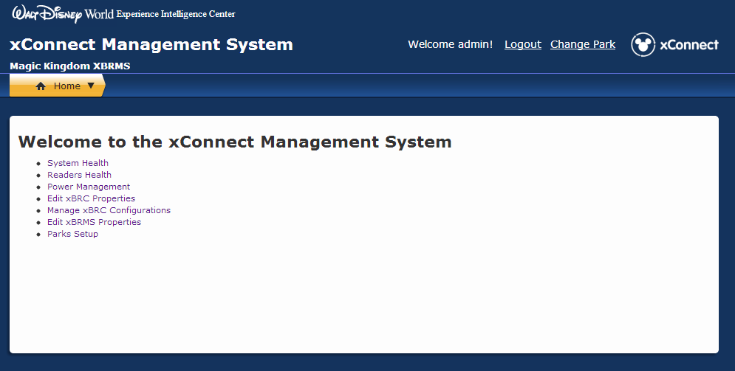

Figure 2: xConnect Management System

# System Health - Monitoring

Select System Health link. The System Health page shows the status of all Monitored applications (xBRCs JMSLISTENERSs, IDMSs).

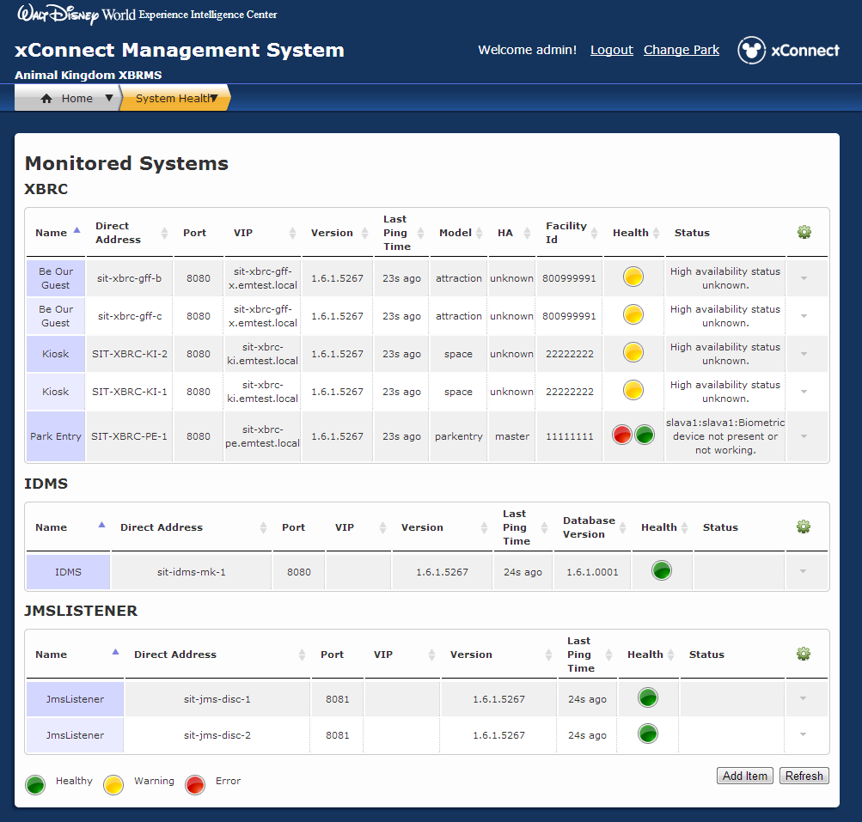

Figure 3: Monitored Systems Page

The System Health page consists of a table grouped by the type of service (xBRC, IDMS, JMSLISTENER) . Each service shows some common columns listed below as well as optional columns specific for that application.

Columns **common** to all monitored services:

| **Column** | **Description** |
| --- | --- |
| Name | Instance name of the monitored application. |
| Direct Address | IP address or hostname of the monitored application. |
| Port | IP Port used to make REST calls to the monitored application. |
| Version | The version of the monitored application. |
| Last Ping Time | How long ago was xBRMS able to contact a monitored application. |
| Health | Green – healthy, Yellow – functioning but with errors, Red – critical errors exists, may not be functioning. |
| Status | Description of the warning or error. |
| http://sit-xbrms-uiep.emtest.local:8080/XBRMSUI/images/configure_16.png | **Actions available for all applications:**  **Details** – More information on the application.  **Delete** - Click to remove the monitored system from the xBRMS. The system will still run, but it will no longer be monitored. Any additional data collected for this system will be permanently deleted.  **Actions available for xBRCs only:**  **Configure** – Link to the xBRC Administration Console.  **Deactivate** – Click to deactivate this item. Deactivating an item removes it from the Monitored Systems page, but doesn’t delete it from the xBRMS database. The item is marked as inactive and any additional data, if collected, is preserved. |

The table describes columns shown on the System Health page that are specific to the xBRC application.

|  |  |
| --- | --- |
| **Column** | **Description** |
| VIP | F5 Virtual IP |
| HA | High Availability status. (master, slave, solo or unknown) |
| Facility Id | The OneSource unique facility id, also known as venue id. |
| Model | The xBRC model type (attraction, space, parkentry) |

### Adding New System to Monitor

The xBRMS is capable of auto-discovering xBRC systems using the JMS message of xbrc_message_type = “DISCOVERY”. This message is periodically send out by all xBRC systems. Other systems, such as IDMS, must be added manually. Follow the steps below to add a new system to monitor.

1. From the Home Page navigate to the **System Health** page.
2. Click **Add Item** at the bottom of the page. The **Add Health Item** dialog will show.

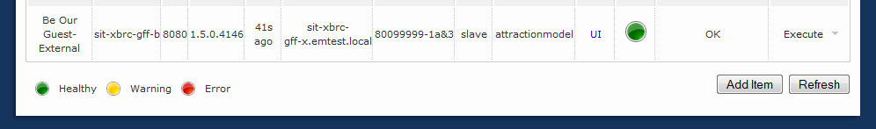

Figure 4: Add Item Button

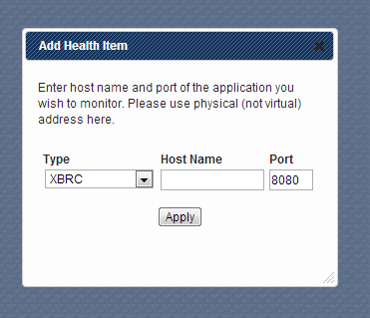

Figure 5: Add Health Item Dialog

1. Under **Type,** select the type of system to monitor.
2. Enter the direct Host Name (not VIP) or Physical IP and Port
3. Press **Apply**.

The specified system will be added to the list right away and its status will be pulled next time the xBRMS status thread wakes up.

### Removing a System to Monitor

To stop monitoring a system and permanently remove all additional data collected for that system, click the arrow button associated with that system in the http://sit-xbrms-uiep.emtest.local:8080/XBRMSUI/images/configure_16.png column (actions column) and select ***Delete.***

**NOTE:** This operation does not uninstall the system.

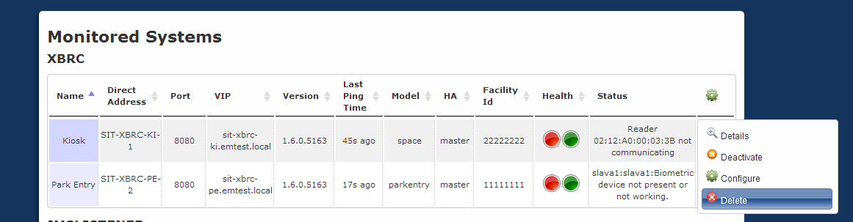

Figure 6: Removing a System

### Deactivating Monitored System

To stop monitoring a system but preserve all additional data collected for that system, click the arrow button associated with that system in the http://sit-xbrms-uiep.emtest.local:8080/XBRMSUI/images/configure_16.png column (actions column) and select ***Deactivate***. Note that this operation does not stop the system itself.

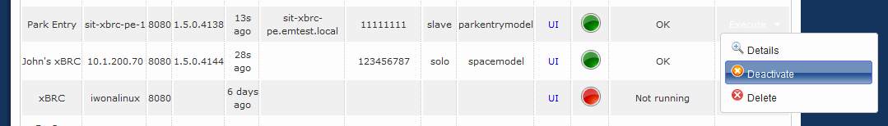

Figure 7: Deactivating a System

### Activating a Previously Deactivated System

To activate a previously deactivated system, follow the steps described in Adding New System to Monitor. If the system you are adding has been monitored by xBRMS before and has simply been deactivated, it will be activated. Otherwise, it will be added.

### Refreshing Monitored System Status

All monitored systems are periodically contacted by the xBRMS to see if they are still alive and to retrieve their health status. To force a refresh, press ***Refresh***at the bottom of the **System Health** page.

**NOTE:** Using the web browser refresh functionality does not force a refresh of the monitored systems’ status. The page will refresh, but since the health status data comes from a cache, the data will stay the same; unless it coincides with the actual health status cache refresh.

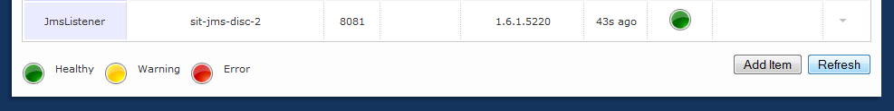

Figure 8: Refresh Button

### Accessing Readers Health Status

To access detailed readers’ health status information for a given facility, click the ***Health*** icon for that facility or the http://sit-xbrms-uiep.emtest.local:8080/XBRMSUI/images/configure_16.pngbutton followed by ***Detail.***

In case of xBRCs running in High Availability mode you will see two ***Health*** statusicons displayed for each facility.

The ***Health*** icon on the left represents the health status of the master xBRC. Clicking that icon will take you to a readers’ health status page as reported by the master xBRC.

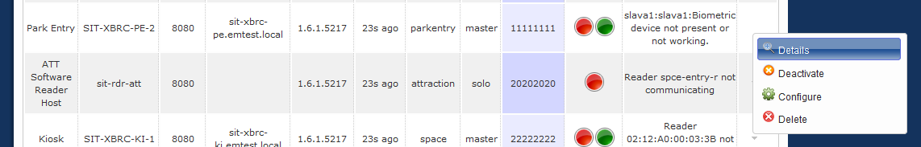

There is no way to view readers’ health information from the perspective of the slave xBRC. The ***Health*** icon on the right represents the health status of the slave xBRC. It also doubles as a button that opens and closes a sub row containing information on the slave xBRC.

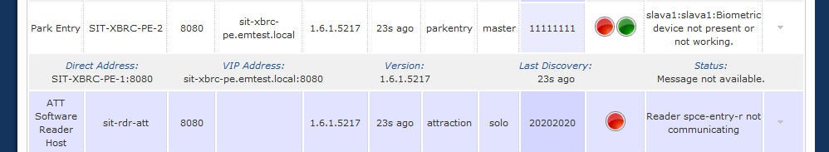

Figure 9: Reader Health Details

The first tab is the Readers’ Health page. The second lists various Performance Metrics for the reader(s).

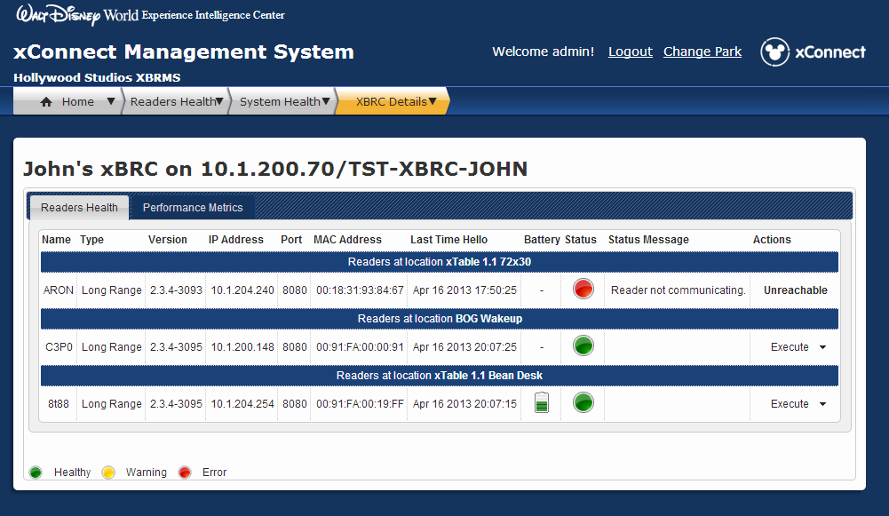

Figure 10: xBRC Details Page – Readers View

### Accessing Performance Metrics

xBRMS collects performance metrics data for each monitored xBRC. To access that data, click the icon in the **Health** column for an xBRC and go to the Performance Metrics tab.

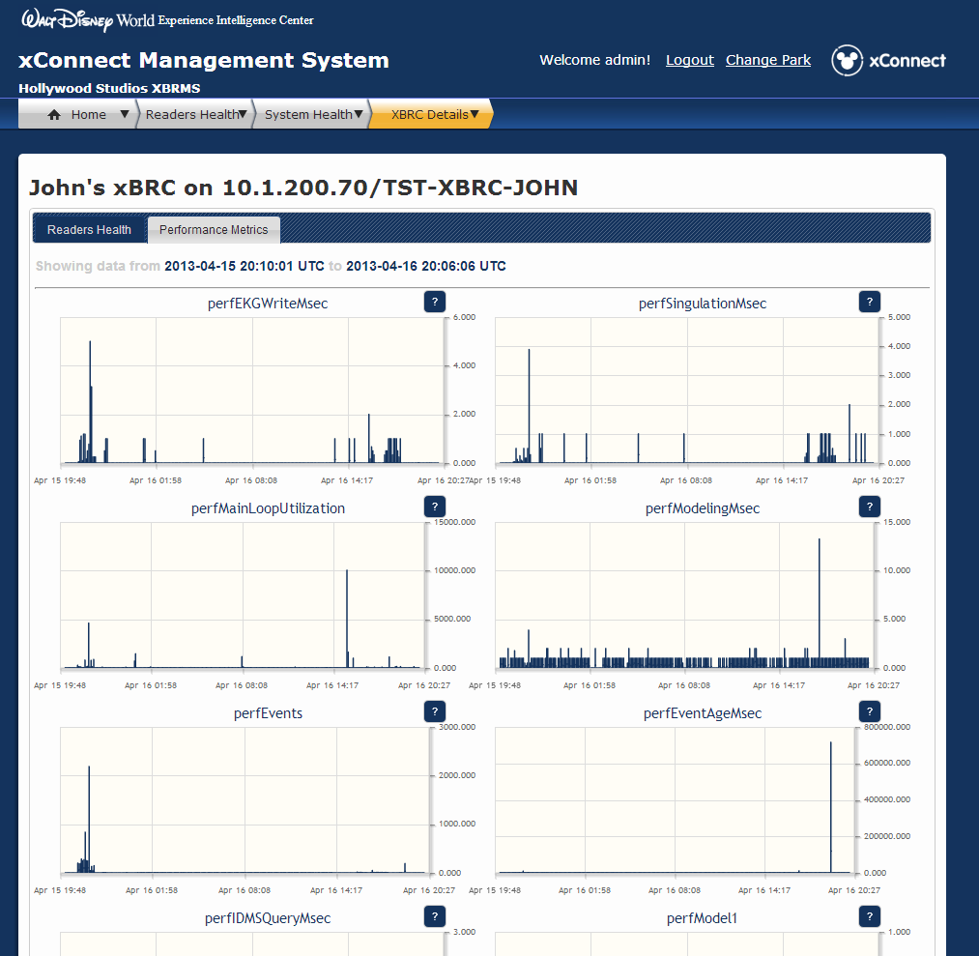

Figure 11: xBRC Details Page – Performance Metric Page

Each xBRC keeps running averages for its performance metrics data. The averages are calculated for ten-minute intervals. xBRMS pulls that data and persists the min, mean, and max for each metric. The performance metrics page shows performance data for the last 24 hours. The time window moves forward every ten minutes.

To view a larger version of a graph, click anywhere inside the graph.

### Readers Health

This Readers Health page groups readers by xBRC and location. This page offers two views: a **Grid View** and a **List View**. The **Grid View** is more concise. The **List View** offers more information.

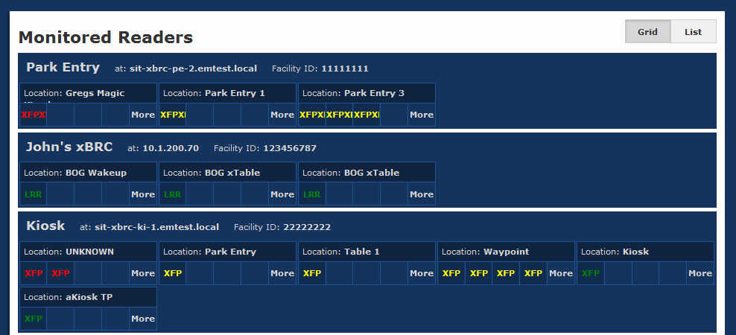

Figure 12: Monitored Readers Health Page – Grid View

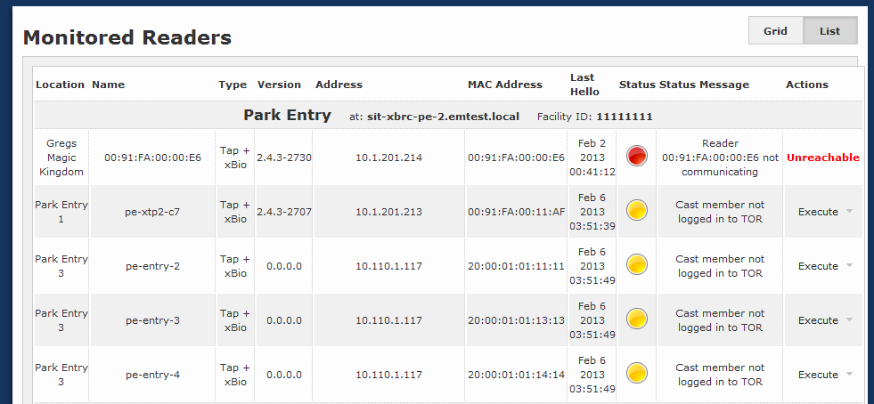

Figure 13: Monitored Readers Health Page – List View

### Reader Commands

There are several commands that can be executed on a reader from this page. If the reader is offline, “**Unreachable**” will appear under the Actions column.

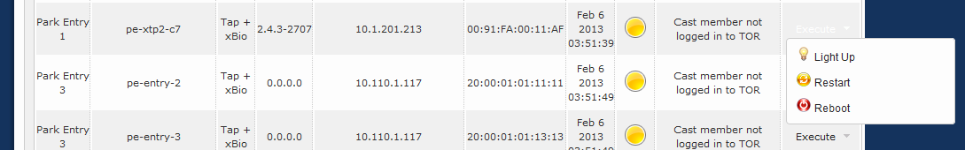

Figure 14: Monitored Readers Health Page – Reader Commands

#### Light Up Reader

This command plays a special yellow media sequence on Touch Point readers to help with visual identification.

#### Restart Reader

This command restarts the reader’s application.

#### Reboot Reader

This command reboots the reader’s operating system.

### xBRMS Health Status

Logging in as admin, the user will see the red New Status Messages on the home page.

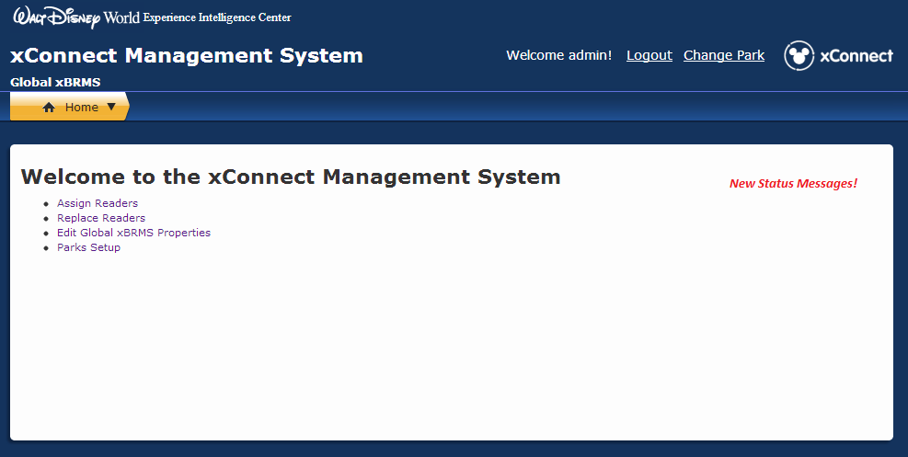

Figure 15: New Status Messages

Clicking on this link will list any current error messages associated with the xBRMS. The user can clear these messages by clicking on the <Clear> button.

# Global Server

## Login in admin mode

Select **Global Server** to bring up the following screen:

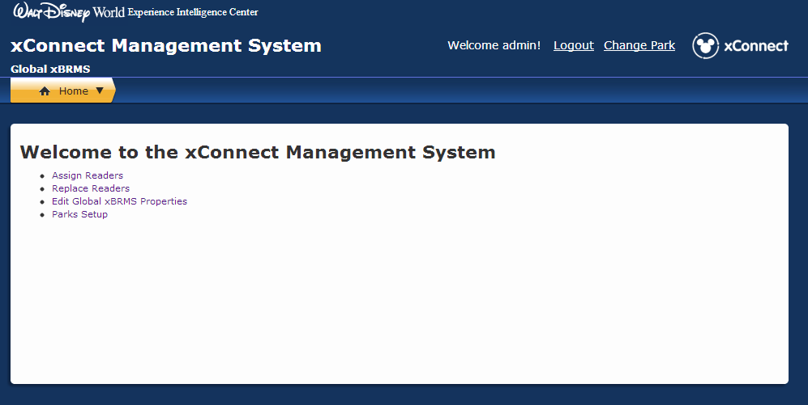

Figure 17: xConnect Management Home Page for Admin

## Login in as Maintenance Mode

Only the **Assign Readers** and **Replace Readers** links will be displayed.

Edit xBRC, xBRMS Properties and Parks Setup are reserved for Admin mode

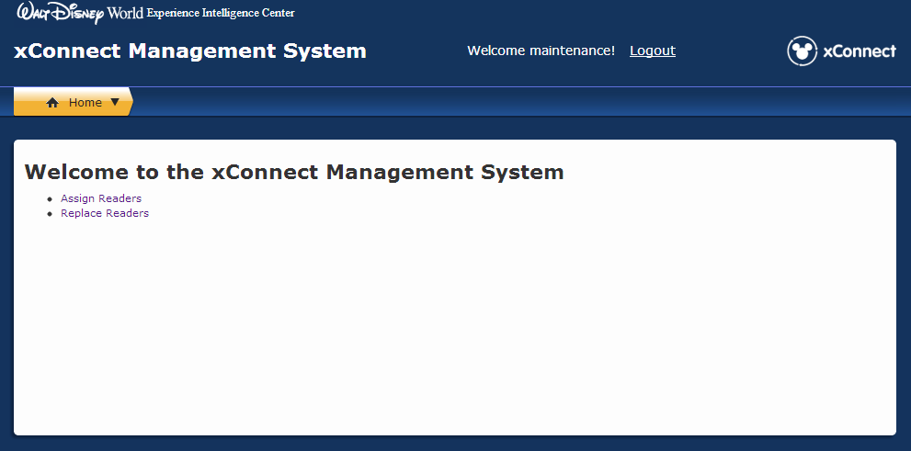

Figure 18: xConnect Management Home Page (Maintenance mode)

## Assign Readers

Readers that are not already configured to say HELLO to a particular xBRC use an SRV record to discover an xBRMS to report to for assignment. Once these unassigned readers report to an xBRMS they are considered “found” and are displayed on the **Assigned Readers** page. Readers are left in the **Found Readers** list until they are manually assigned to an xBRC.

In order to assign a reader to an xBRC, you can either type in that xBRC’s VIP address into the text field provided or select an xBRC from the list of monitored xBRCs. Once you’d specified which xBRC should your reader be assigned to click ***Assign***.

Please note, that only xBRCs in a valid HA state will be made available in the list of monitored xBRCs. An example of an invalid HA state would be an xBRC with HA enabled but for which VIP has not yet been configured.

The **Found Readers** screen shows a list of all unassigned readers and a drop-down list which allows you to either enter a VIP address or choose an xBRCs out of all monitored xBRCs in a valid HA status.

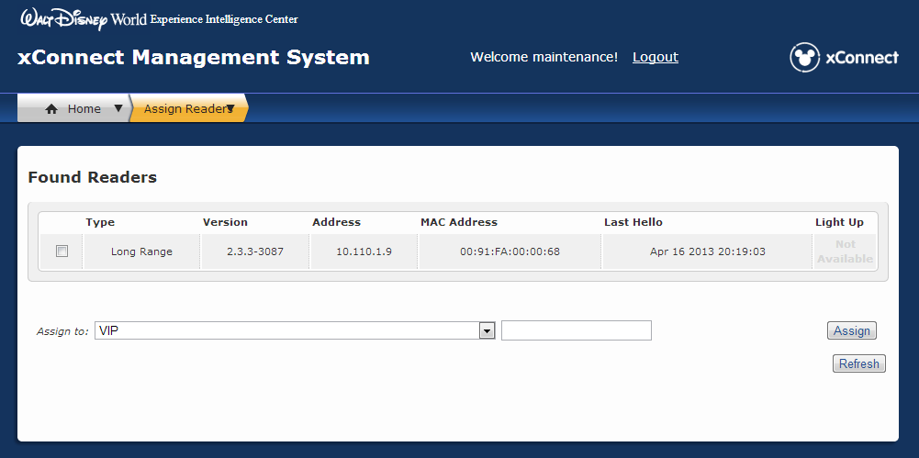

Figure 19: xConnect Found Readers screen

1. Find the MAC Address for the new reader, and check the box to select it in the **Found Readers** list.

**Note:** All readers are assigned a unique MAC Address, which is affixed to the device on a white sticker. If you don’t already have the MAC Address for the new reader that was installed, ask the Field Technician to provide it.

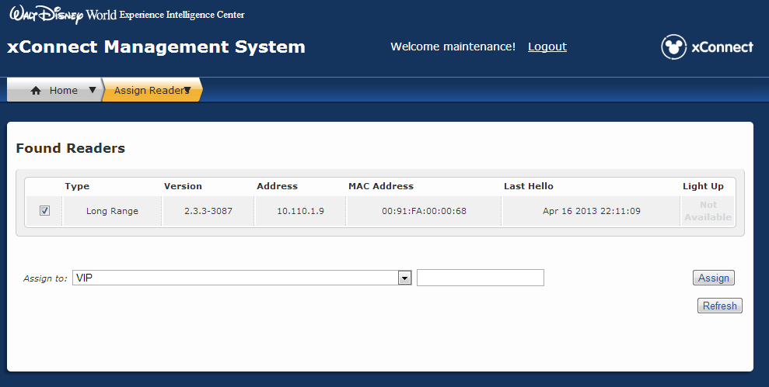

Figure 20 – xConnect Found Readers list

For xTPs (tap readers) click the light bulb icon in the **Light Up** column. This will cause the xTP to flash its light, confirming that you are assigning the correct reader.

Tip: When **Light Up** is selected, the xTP face plate will display a yellow light sequence for 60 seconds. This validates that you are linking the correct replacement device before completing the replacement process. Once the light sequence begins, the Command Center Technician can resume the replacement process. You don’t need to wait until the light sequence completes—the lights will turn off automatically.

Update Screen

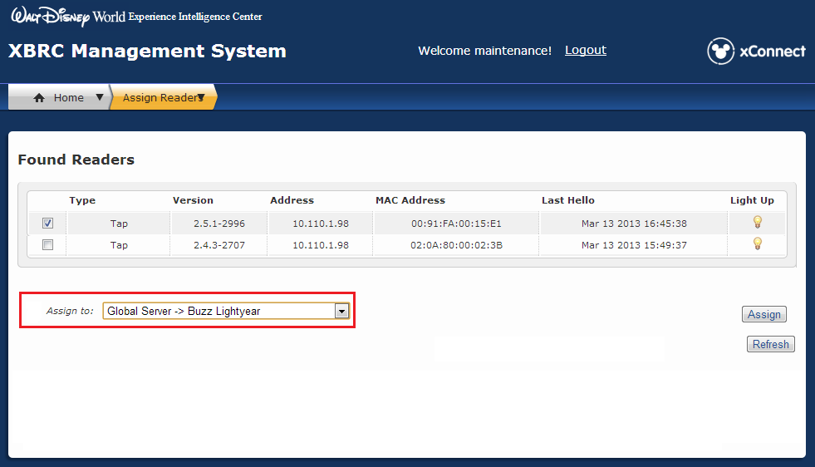

Figure 21– Light up xTP

With the reader selected in the list, expand the **Assign To** drop-down list and choose the xBRC that you want to assign this reader to. The xBRC is usually named after the attraction.

Update Screen

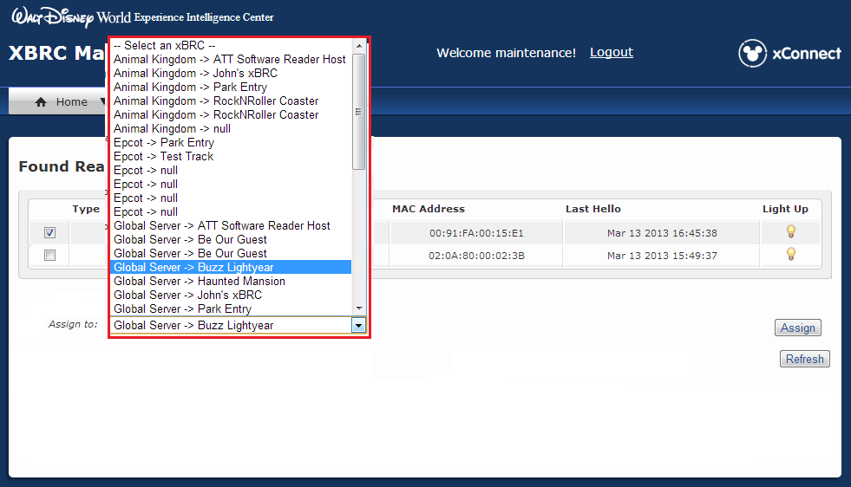

Figure 22 – List of all xBRCs

Select the xBRC that you want to assign the selected reader to.

Update Screen

 Figure 23 – Select an xBRC

Click on **Assign** button and then a **Success** message appears, confirming that the reader has been assigned to the xBRC.

Update Screen

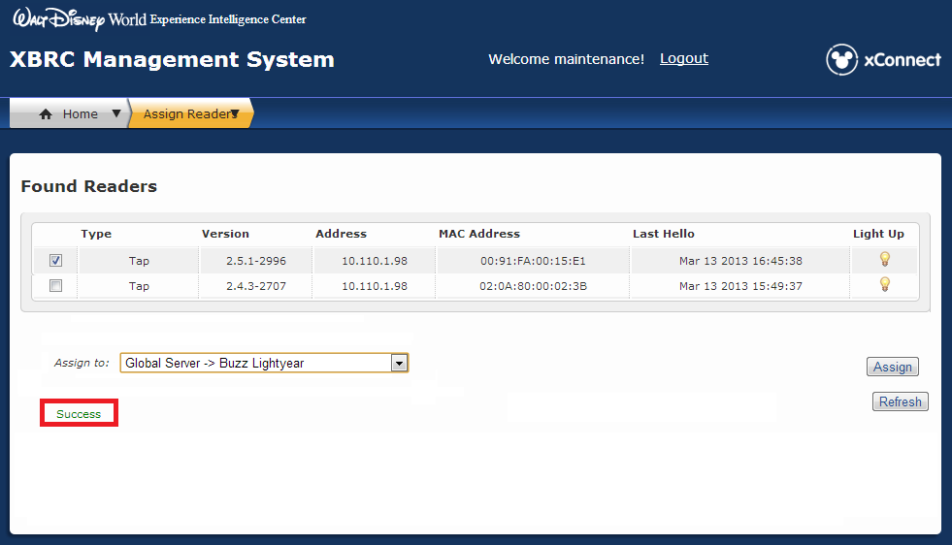

Figure 24 – Success confirmation

Now that you have assigned the reader to the right xBRC, you can replace the reader with a new one.

## Replace Readers

On the **xConnect Management System Home** page, click the link for **Replace Reader**.



Figure 25 – Replace Readers command

On the **Replace Reader** screen, select the reader you would like to replace, by expanding the **Select Park** drop-down list to show all parks with readers that display a yellow or red Health status in xBRMS.

For this example, we are using **Magic Kingdom**.

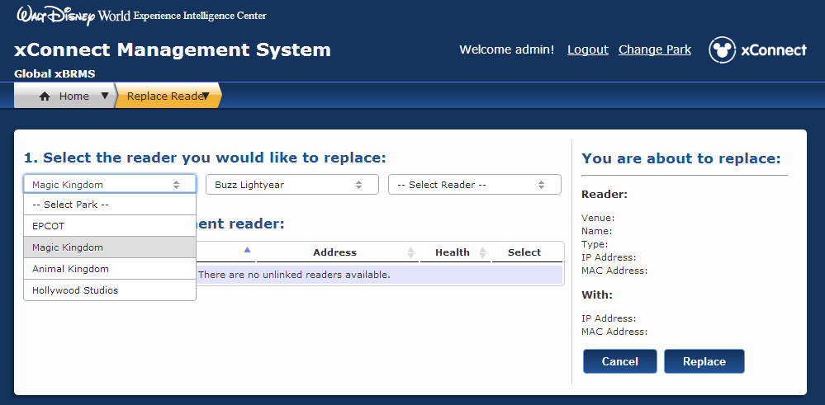

Figure 26 – Select Park

On the **Replace Reader** screen, expand the drop-down list for **Select Venue**,todisplay a list of all available venues for the park.

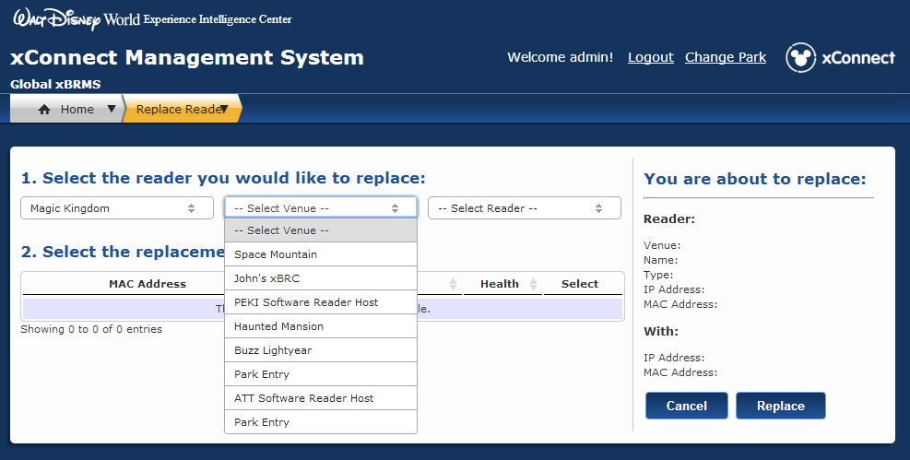

Figure 27 – Select Venue

Choose the venue within this park for the reader that needs to be replaced. For this example, we are using **Buzz Lightyear**.

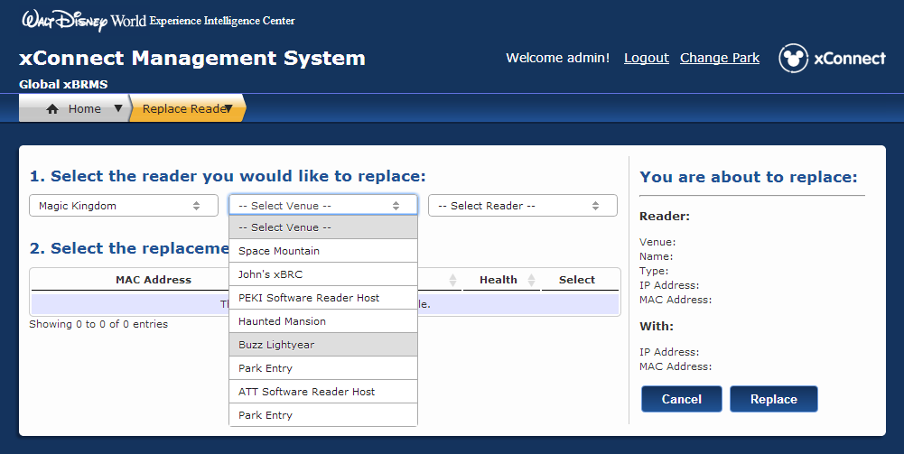

Figure 28 – Select the venue for this park

Choose the reader to replace for this park and venue. For this example, we are using **hm-merge-tap-1**.

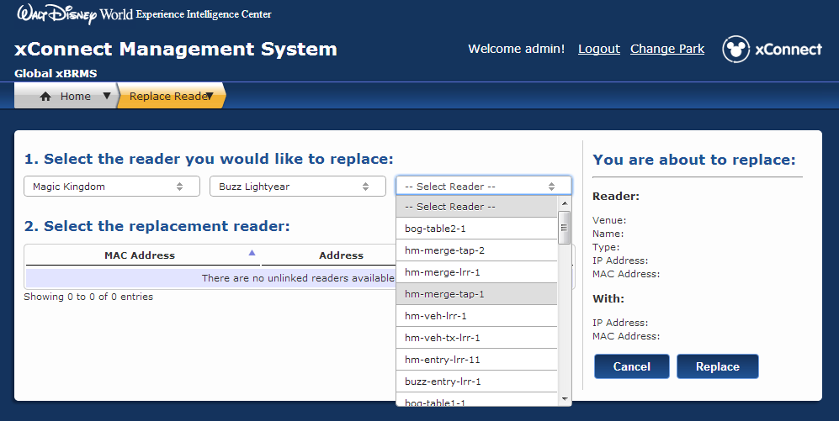

Figure 29– Select the reader to be replaced

Once you have selected the reader to be replaced, a list of all replacement candidates for this type of reader appears under step **2**. **Select the replacement reader**.

**Important**: If you don’t see the reader you’re looking for in the list, it may first need to be assigned to the correct xBRC before it can be managed correctly in the Replace Reader process. If you don’t find the reader in the list, click the **Home** tab and click the **Assign Readers** link, then follow the steps in the Assign Readers section.

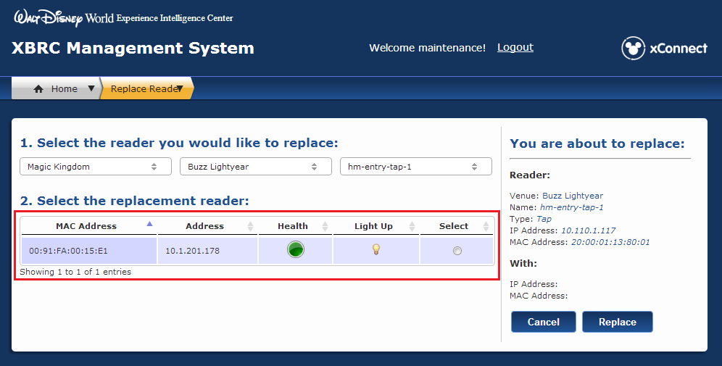

Figure 30 – Replacement reader candidate list

Select the reader to use for this replacement. For this example, we are using the unlinked reader with the MAC Address 00:91:FA:00:15:E1.

**Tip**: For xTP readers (for FastPass+, for example), click the light bulb icon to “light up” the reader face plate. When clicked, the xTP will display a yellow light sequence for 60 seconds. This validates the correct replacement device before completing the replacement process. Once the light sequence begins, the Command Center Technician can resume the replacement process. You don’t need to wait until the light sequence completes—the lights will turn off automatically.

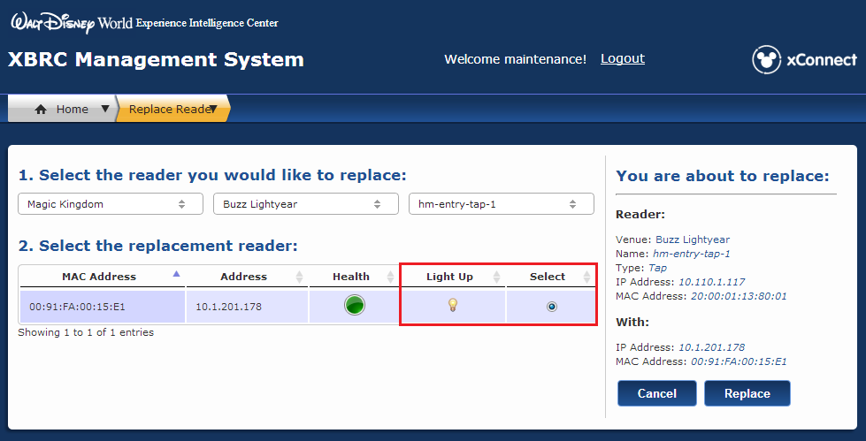

Figure 31 – Replacement readers list with Light Up icon

**Important**: The **Health** column provides information about the performance of all replacement reader candidates, displaying green, yellow or red light icons. The health status for a newly installed reader should always be green. If it is red, verify that all physical connections are secure and cycle power. If after two minutes the status condition is still red, try installing another device or escalate the issue.

## Edit Global xBRMS Properties

See Section Edit Global xBRMS Properties for details.

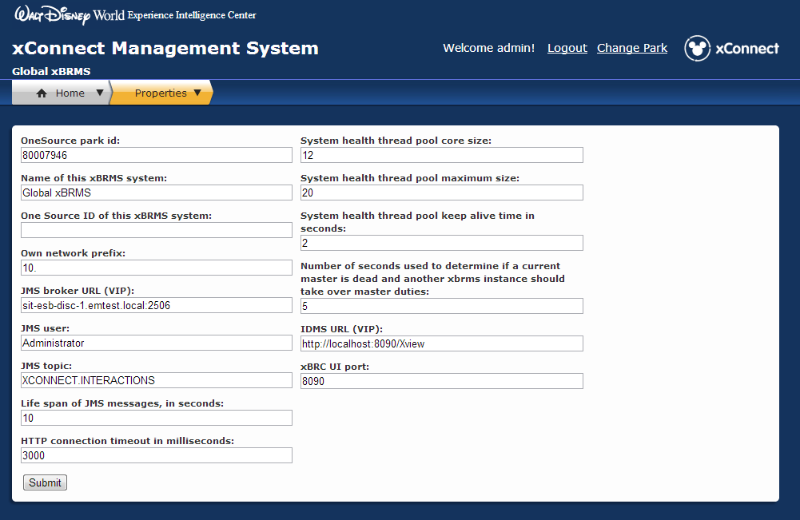

Figure 32 – xBRMS Global Configuration page

## Parks Setup

Architecture of xBRMS application can be roughly simplified to two components xBRMS Server and xBRMS UI. In production there is one xBRMS Server HA group deployed per park and one xBRMS Server HA group acting as the Global xBRMS Server. Each xBRMS UI HA group is capable of providing User Interface for one-to-many xBRMS Server HA groups.

The **Parks Setup** page allows the xBRMS administrator to add xBRMS Server HA groups to the xBRMS UI HA group.

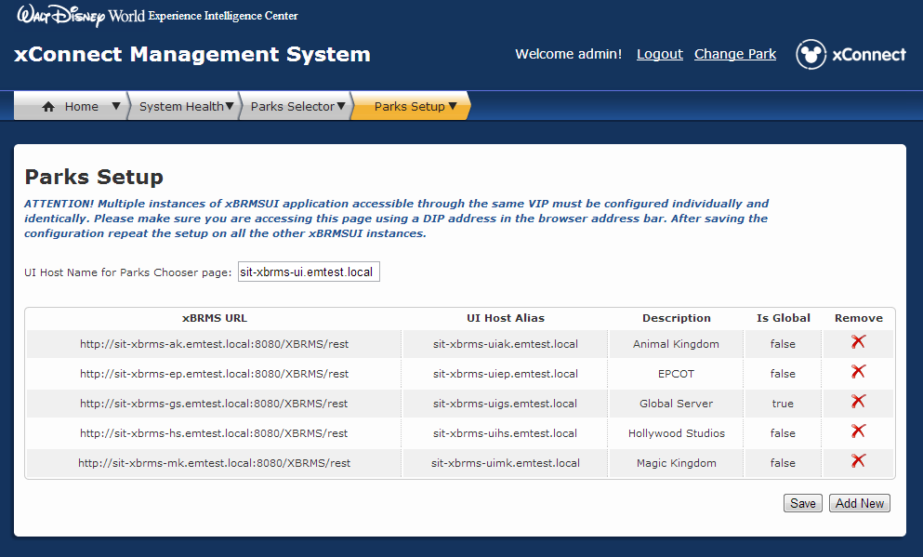

Figure 32 – Parks Configuration page

In order to configure the xBRMS UI to provide access to data and functionality implemented by the xBRMS Server(s) you will need to know the following information:

|  |  |  |
| --- | --- | --- |
| **Parameter** | **Definition** | **Unique?** |
| **UI Host Name for Parks Chooser page** | VIP Hostname for the xBRMS UI you are configuring | Yes |
| **xBRMS URL** | URL to an xBRMS Server VIP Hostname in the following format:  *http://<VIP Hostname>:<VIP Port>/XBRMS/rest* | Yes |
| **UI Host Alias** | CNAME pointing to the VIP Hostname provided in “UI Host Name for Parks Chooser page” | Yes |
| **Description** | Name for that xBRMS Server. For example: Animal Kingdom or Global Server. | Yes |
| **Is Global** | A flag marking one of the xBRMS Servers added as global. False by default. There can only be one global xBRMS server. | Only one “True”, but many “False” |

Please note that only one xBRMS HA group can be marked as Global. Also note that all instances of xBRMS UI in the same HA group must be configured individually and identically. Please make sure that you are accessing the Parks Setup page using a DIP address in the browser address bar. After saving the configuration on one instance of xBRMS UI HA group repeat that same setup on all the other instance of xBRMS UI in your HA group.

# xBRC & xBRMS Configuration

## Edit xBRC Properties

The xBRMS allows modifying parameters of running xBRC applications. To make configuration changes, each xBRC system to be configured must be running. The **xBRC Configuration Edit** page allows for modifying parameters for a single xBRC or multiple xBRCs.

The parameter changes are effective as soon as **Update Selected xBrc(s)** is pressed. For most parameter changes, the xBRCs do not need to be restarted. The exception is the ESBInfo section settings, which defines the JMS broker settings, and venue id. When changes to these parameters are made the xBRC must be restarted for these changes to take effect.

The following figure shows the components of the **xBRC Configuration Edit** page.

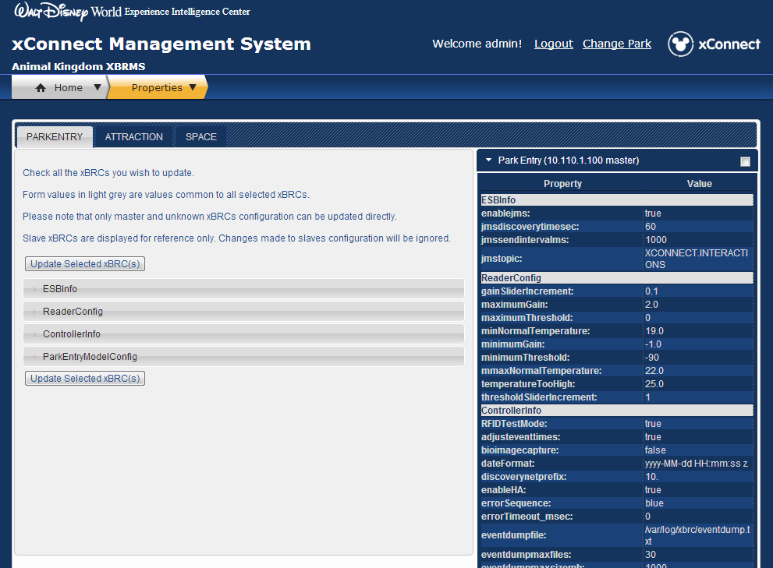

Figure 33 xBRC Configuration Edit

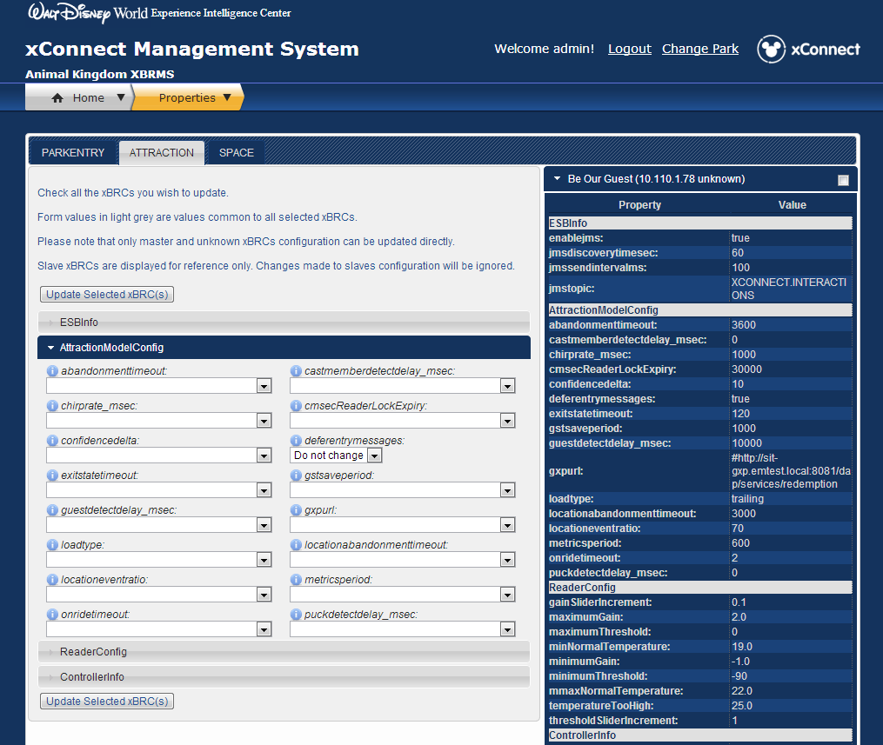

Figure 34 xBRC Configuration Edit Expanded

To edit one or more xBRCs:

1. Select the checkbox for each of the xBRCs to modify.  
     
   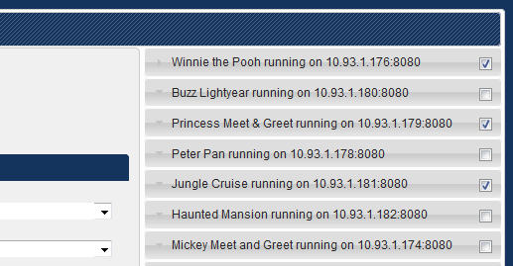

Figure 35 Configuration Edit – Selecting xBRC(s)

1. Make modifications to the configuration parameters.  
     
   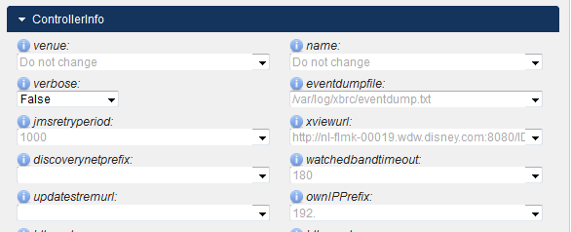

Figure 36 Configuration Edit - Modify Params

Note that when updating multiple xBRCs, the properties that are not the same for all the selected xBRCs will show the “Do not change” text.

1. Press **Update Selected xBrc(s)** to save your changes.
2. If the ESBInfo section or the venue id was changed, restart the xBRC(s).

## Manage xBRC Configurations

The xBRMS allows you to maintain a repository of xBRC configurations. Each xBRC configuration is an XML document containing the entire configuration for the xBRC. This includes the Mayhem.Config table entries, list of locations and list of readers at each location, and the configuration of the **Facility View**web page. It is also possible to store partial configurations containing a subset of the entire configuration. Currently, partial configurations must be edited by hand and uploaded as an xml file.

The **Manage xBRC Configurations** page allows the following operations:

* Retrieval of full configuration from a running xBRC (Download)
* Deploying a stored configuration to a running xBRC (Deploy)
* Removing of a xBRC configuration (Remove)
* Uploading a configuration from an xml file (Add New)

The following figure shows the stored **xBRC Configurations**.

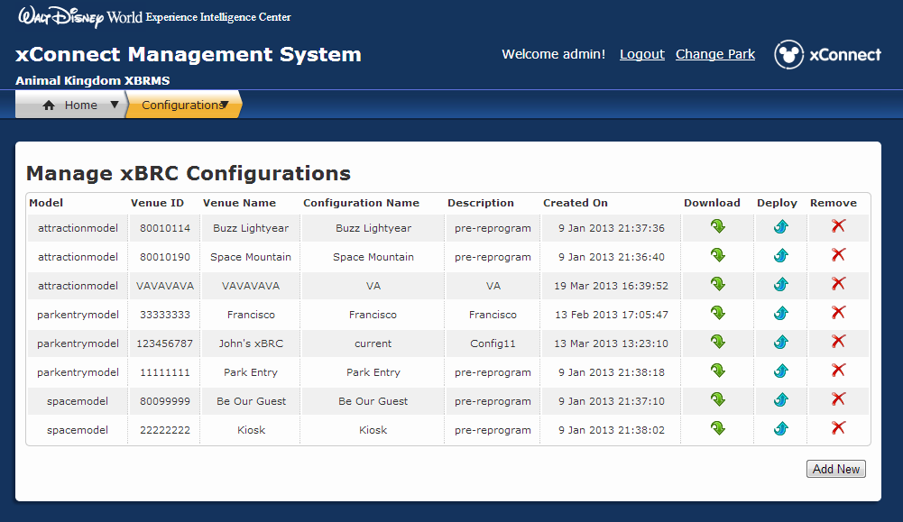

Figure 37 Manage xBRC Configurations

### Add a stored xBRC Configuration

Click **Add New** at the bottom of the page.

The following dialog will show:



Figure 38 Add xBRC Configuration

1. If uploading configuration from a running xBRC, click on the green refresh icon to auto-populate the form fields.
2. If uploading configuration from a file, select **Upload XML configuration file** and browse for the xml file on your local computer.
3. Enter the required form fields and click **Submit**to store the configuration in the xBRMS database.

Note that the list of running xBRCs from which you can upload a stored configuration will only contain xBRCs in a valid HS state that are not slaves.

### Deploying Stored Configuration

Deploying a stored configuration pushes all the settings from a stored configuration to a running xBRC. Some configuration changes may require the xBRC to be restarted depending on the differences between the current xBRC configuration and one being deployed. It is recommended to re-start the xBRC after a stored configuration is deployed.

To deploy a stored configuration:

1. Click the blue arrow icon on the right side of the stored configuration row.  
   
2. The **Deploy xBRC Configuration** dialog will show. A table with a description of the stored configuration is shown.

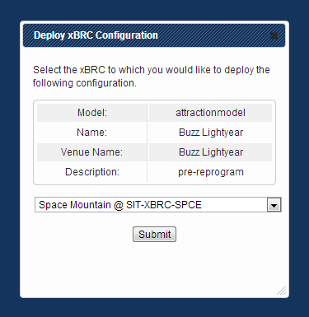

Figure 39 Deploy xBRC Configuration

1. From the drop down list, select the xBRC to deploy the configuration to.
2. Click **Submit**.
3. Restart the xBRC. This step may be skipped if there are no significant difference between the current configuration of the xBRC and the configuration being deployed.

It is possible to deploy a stored configuration to xBRCs in all HA status types.

### Downloading a Stored Configuration



Press the green arrow icon on the right side of the stored configuration row to download a stored configuration to a file on your local computer.

### Removing Stored Configuration

Press the red cross icon on the right side of the stored configuration row to remove a stored configuration from the xBRMS database.

## Edit xBRMS Properties

The **Edit xBRMS Properties** page allows for modifying of xBRMS configuration properties. Configuration properties which, according to NGE standards, must be encrypted and can only be specified in the environment.properties file, are displayed on a grey background and may not be changed.

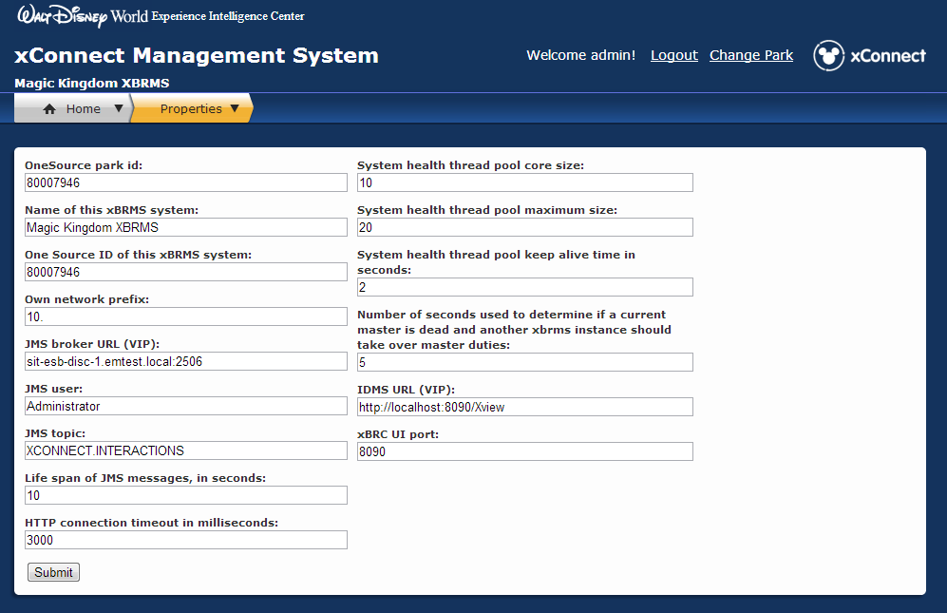

Figure 39 Edit xBRMS Parameters

| **Parameter** | **Description** | **Requires Restart** |
| --- | --- | --- |
| OneSource park id | OneSource ID assigned to the park | No |
| Own network prefix | Network prefix of this xBRMS system | Yes |
| Life span of JMS messages | Life span of JMS messages in seconds | Yes |
| HTTP connection timeout in milliseconds | Timeout of HTTP connections | Yes |
| System health thread pool core size | Initial size of the connection pool used by the health monitor | Yes |
| System health thread pool maximum size | Maximum size of the connection pool used by the health monitor | Yes |
| System health thread pool keep alive time in seconds | Keep alive period for determining if a pooled connection is alive | Yes |
| Number of seconds used to determine if the current master is dead | Number of seconds before HA failover takes place when the current master is detected to be dead (unresponsive). | Yes |
| JMS broker URL (VIP) | The Sonic MQ JMS broker URL in the form <ip>:<port>. Virtual IP is expected. | Yes |
| JMS user | Username to be able to connect to the Sonic MQ JMS broker. | Yes |
| JMS topic | Default: com.synapse.xbrc. This is the topic on which the DISCOVERY message is sent from the xBRC. | Yes |
| Name of this xBRMS system | This name is passed to other system in the /rest/facilities REST call. | No |
| IDMS URL | URL of the IDMS system. | No |
| Guest Cache Refresh Period in Seconds | How long to keep cached guest information obtained during the Guest Search operation. | Yes |
| xBRC UI port | The web server port of the xBRC UI web service. Default: 8090 | No |
| OneSource ID of this xBRMS system | Every application at Disney is assigned a unique id which are generated by OneSource | No |

# Power Management

The Power Management page allows temporarily turning on long range readers (overriding the schedule) in xBRCs which have an xBR (version 4) with an attached battery. See the document *900-0058 Rev 1.6 xBRC Interface Control Document.docx* for details about setting the start and stop hours.

If no xBR’s were found, the following message will be displayed:

***No xBRCs with an xBR powered by a battery were located*.**

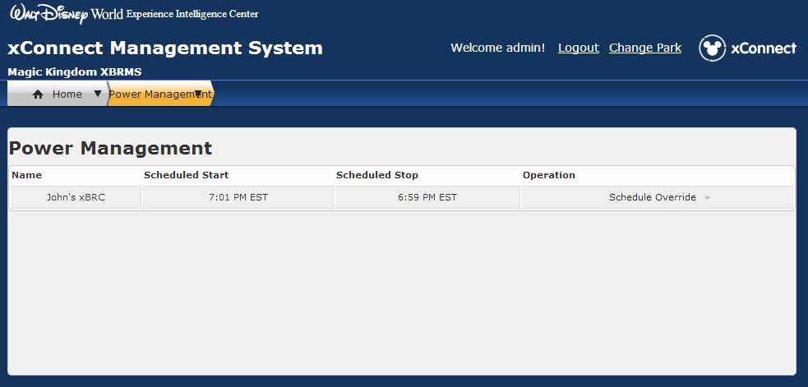

Figure 40 Power Management Screen

All overrides are temporary to prevent inadvertently leaving a device powered on for an extended length of time.

Executing an override while readers are currently scheduled to be on has the effect of (temporarily) moving the schedule off time by the specified amount.

Readers may only be turned on – you cannot turn off devices during scheduled hours. You may, however, clear an existing override.

Note that overriding the schedule may not have an immediate effect. Readers that are supposed to be off will periodically turn on and check in with their xBRC. If the xBR is to remain off, the xBRC will instruct the xBR to turn off for some limited duration (in the range of a minute to two hours). At which point the cycle begins again. Overriding the schedule (or changing the schedule) will only affect the device when it turns on.